COMMUNICATIONS MANAGER
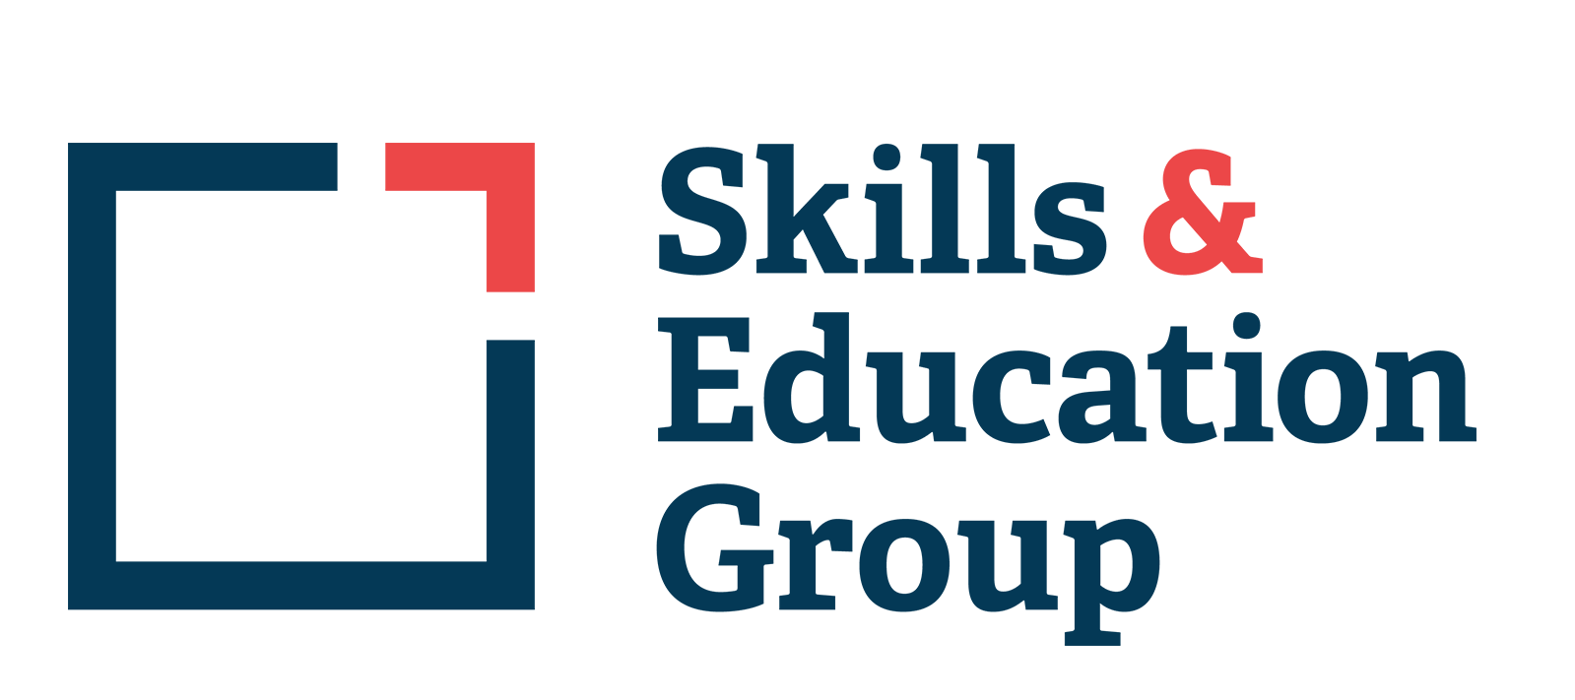

PERSON SPECIFICATION

Essential/

Desirable

Qualifications
- Good standard of general education to A level or above (or equivalent) including English Language | E
- Marketing qualification | D
- Project management course or qualification | D

Knowledge and Experience
- Previous experience of creating and managing digital marketing campaigns | E
- Project management experience | E
- Experience of working in a general marketing-related role | E
- Experience of copywriting and proofreading
- Experience of working in a busy office with a strong collaborative ethos | E
- Experience of leading a team | E
- Knowledge of or interest in the UK Education system and current affairs | D

Skills
- Excellent written and verbal communication skills, including presenting information logically and concisely in ways that promote understanding | E
- Strong attention to detail, highly accurate, with excellent language and grammar skills | E
- All-round marketing and communications skills | E
- Ability to prioritise, plan and organise day to day activities, ensuring timely achievement of campaign and project goals | E
- Excellent IT skills, including Microsoft (Outlook, Word, Excel, Teams) | E
- Experience with using marketing and project management platforms such as WordPress, Mailchimp, social media scheduling platforms, Canva, and Asana | E
- Organisational and time management skills with the ability to multitask within a busy office environment | E
- Good interpersonal skills: utilising assertive, honest and respectful communication | E
- Effective problem-solving and strategic thinking | D
- Ability to compile, interpret and present statistical information | D

Personal Attributes
- Confident communicator: able to lead and contribute to meetings | E
- The ability to use own initiative and know when to seek advice | E
- Committed to high standards of quality, seeks to improve systems and processes | E
- Ability to work under pressure to tight deadlines | E
- Ability to develop and maintain strong, effective and professional working relationships
- Committed to continuous self-development | D
- Flexible and receptive to change | D

December 2023

